**Color Models**

**Lesson Agenda:**

* **What is Color Model?Names of Color Model.**
* **RGB Color Model Properties.**
* **CMY Color Model Properties.**

**What is Color Model?Names of Color Model.**

1. A color model is a method of describing a color.
2. There are many color models. Some of them are RGB(red, green, blue), CMY(cyan, magenta, yellow),CMYK( Cyan, Magenta, Yellow and Black.), YIQ, HSV(hue, saturation, value) , and HLS(hue, lightness, saturation), etc.

**RGB Color Model Properties.**

1. The name of the model comes from the initials of the three additive primary colors red, green and blue.
2. **RGB** stands for **Red**, **Green**, and **Blue**.
3. This color space is widely used in computer graphics.
4. RGB are the main colors from which many colors can be made.
5. The color is expressed as an RGB triplet (r, g, b), each component of which can vary from zero to a defined maximum value.
6. If all the components are at zero the result is black; if all are at maximum, the result is the brightest representable white.

Black: RGB(0,0,0)

White: RGB(255,255,255)

Red: RGB(255,0,0)

Green: RGB(0,255,0)

Blue: RGB(0,0,255)

Yellow: RGB(255,255,0)

Magenta: RGB(255,0,255)

Cyan: RGB(0,255,255)

1. How many colors are in RGB model?

256 x 256 x 256 = 16777216 possible colors!

1. 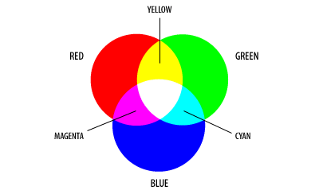

For each primary color, it is possible to take 256 different shades of that color. So by adding 256 shades of 3 primary colors, we can produce over 16 million different colors

9.The concept RGB color model is used in **Display monitor**.

10.Primary colors are red, green, and blue

* + Combining red + green + blue yields white

11.RGB24 is a 24 bit color format. Every pixel is represented by 3 bytes, while every byte of this triple corresponds to one color value. The letters 'RGB' mean Red, Green and Blue, so one byte represents the red value, one byte represents the green value and the last byte represents the blue value.

12.32-bit color, in a RGB color space, is a color depth that can theoretically allow for up to 4,294,967,296 unique colors.In the 32-bit RGB color representation, an extra 8-bit channel for transparency is included to 24-bit RGB representation. The transparency channel is commonly known as the alpha channel, so the format is named RGBA.

13.RGBA is not a distinct color model.Many assume that 32-bit RGB color produces 4,294,967,296 distinct colors.In reality, 32-bit RGB color actually refers to 24-bit RGB color.

**CMY Color Model Properties**

* Secondary colors are cyan, magenta, and yellow
* Combining cyan + magenta + yellow yields black.

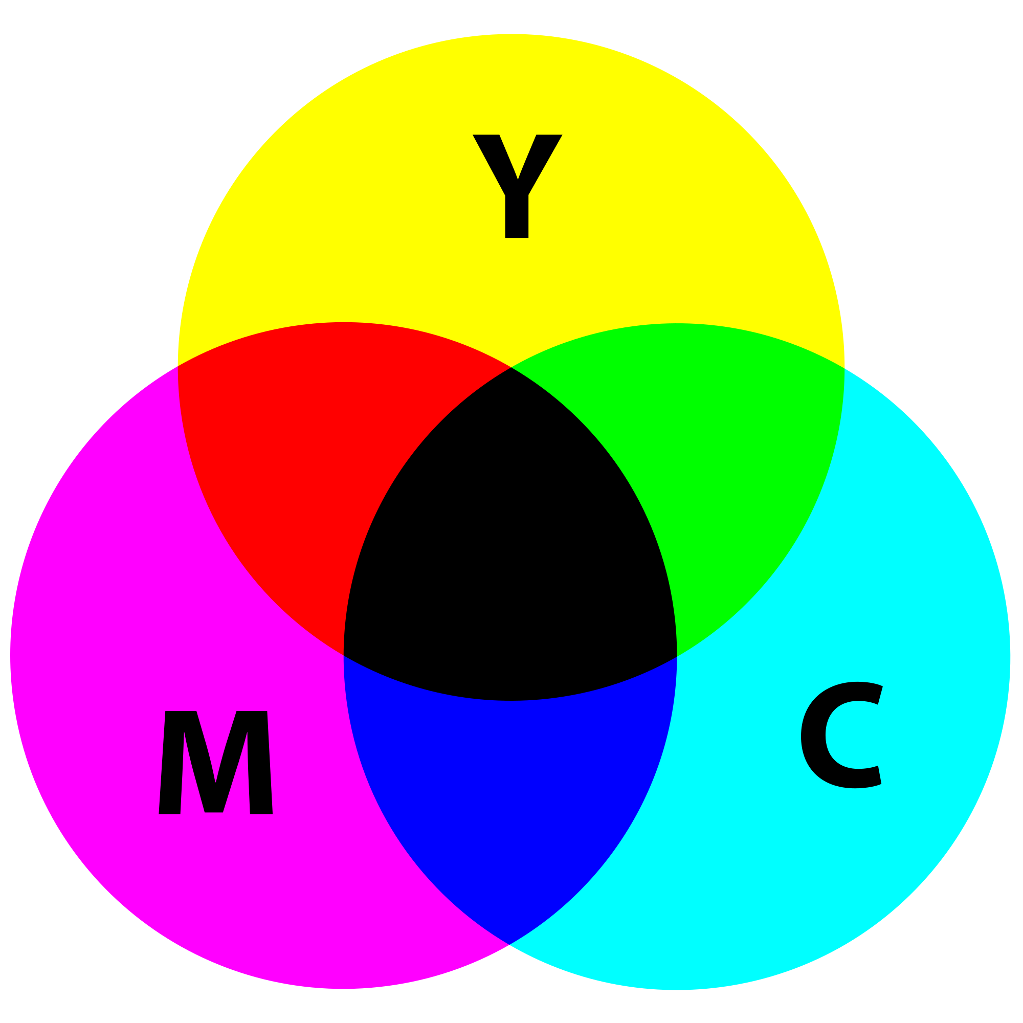

* The following formulas summarize the conversion between the two color models:

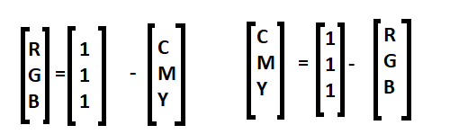

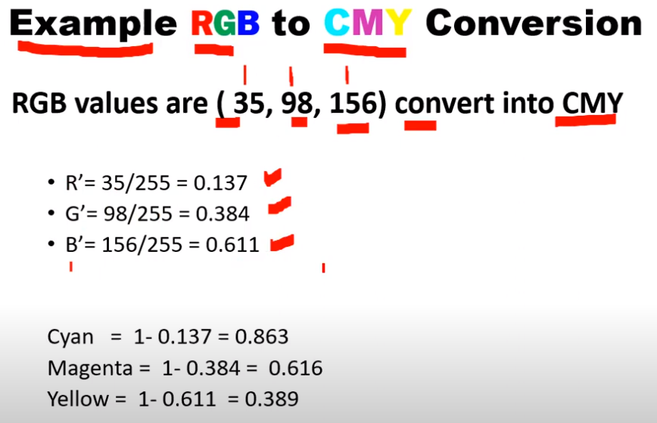

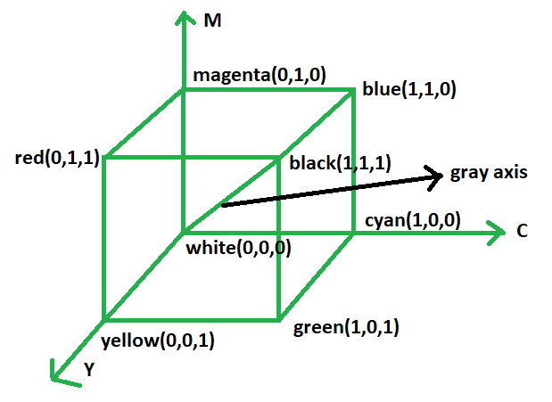

* **According to the color wheel shown above, equal amounts of cyan, magenta, and yellow should produce black.**
* **The addition of black in this model results in it being referred to as the CMYK color model.**

### **YUV/YCbCr Color Model**

* **The YUV color model is the basic color model used in analogue color TV broadcasting.**
* **Y= luminance, UV=Chromaticity**

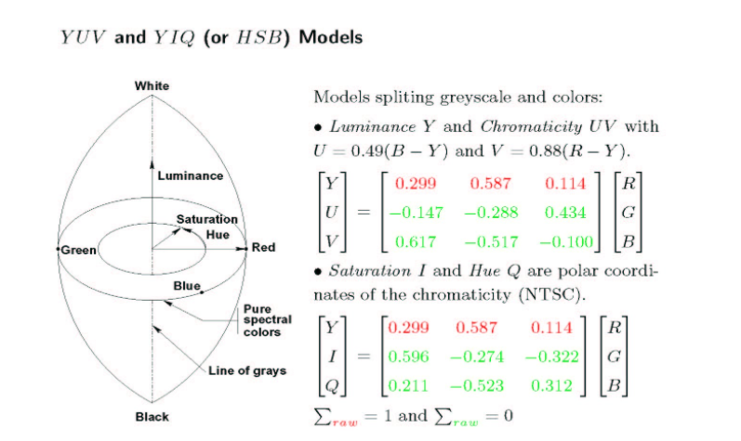

* **From RGB to YUV**

**Y = 0.299R + 0.587G + 0.114B**

**U = -0.147R - 0.289G + 0.436B**

**V = 0.615R - 0.515G - 0.100B**

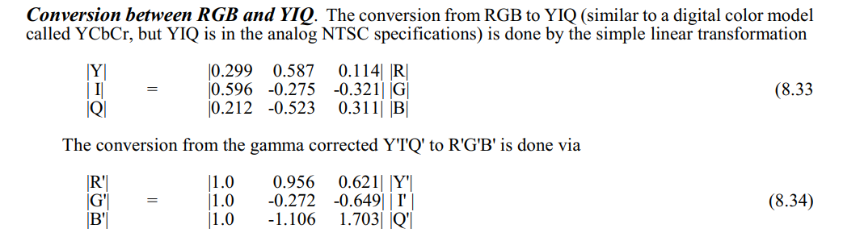

**RGB to HIS and vice versa**

